Warning devices  Verify Check  Horn  Amber flashing beacon  Reversing alarm  Verify Check  Warning signs (in cabin)  SEAT BELTS MUST BE WORN  Verify Check  DANGER – BEWARE OVERHEAD WIRES,  PIPES and SERVICES | Supplier verification & Plant details |  |  |  | 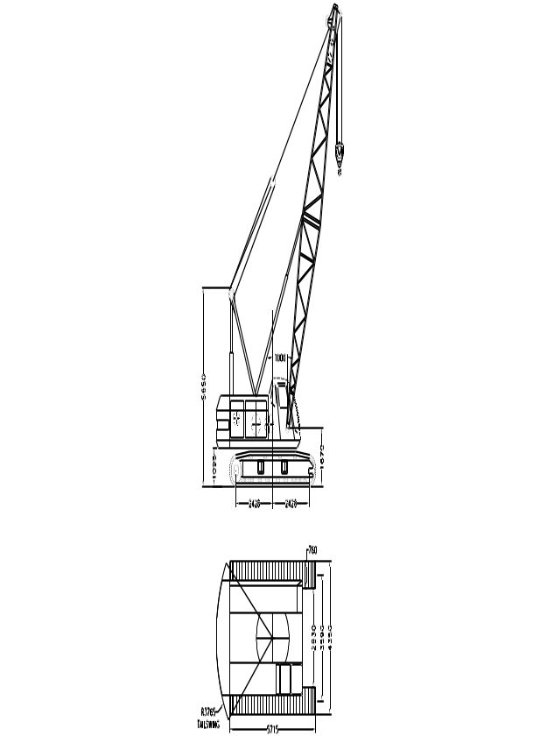  Verify Check  Pivots  Connecting rods  Safety pins  (no excessive wear)  Boom  Verify Check  Cab  Cleanliness  Seat condition OK  Operator restraint provided  Instruments operational & labeled  Levers / controls operational  Pedals in good condition  ROPS to AS 2294  Windows / wipers / washers  Rear view mirrors  Operator instruction  (available on plant)  Log book  SWL / crane chart  Hydraulics  Verify Check  Rams  Hoses  Connections  (check for excessive  wear, leaks and creep)  Verify Check  Handrails  Steps  Verify Check  Engine guarding  Verify Check  Exhaust  Verify Check  Tracks complete  Idlers adjusted  Drivers free from leaks  Tracks
 | Plant owner:
 | Address:
 | City/Suburb:
 | Phone:
 | Plant make:
 | Plant model:
 | Serial no.:
 | Signature:
 | Date:
 | Work Cover Certification – C2 or C6
 Plant to conform to manufacturer’s specifications and Plant Regulations.
 Plant operator is to provide daily checksheets to WDA on a weekly basis
 Where applicable, Personal Protective Equipment must be worn.
 Plant Log Book detailing service history in accordance with Manufacturer’s specifications should be written legibly in English.
 Contractor must produce proof of competence of operator, e.g., Certificate of Competence, Licence, detailed Log Book
 | WDA use only
Verify Check  Slings / ropes / chains (tagged and in good working order)  Electrical wiring (no visual signs of damage)  Steel or timber pads | Note: Sign only when all items have been checked
 | Plant check by:
Instructions:  Verify Box to be ticked by Owner / Supplier / Operator prior to arrival onsite.  Check Box to be ticked after visual inspection by WDA | Position:
 | Date: |  | / /

